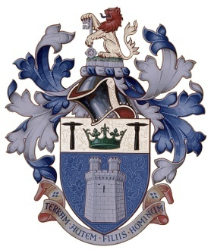Institute of Quarrying

Northern Ireland Branch

**Chairman**: **Hon. Secretary**:

Pierce Kirwan Matthew Greer

152 Portaferry Road 9 Riverhill Manor

Newtownards Ballyclare

Co Down Co Antrim

BT22 2AJ BT39 9ZH

Mob: 02891814781 Work: 028 79651327

Work: 07921541444 Mob: 07929690700

E-mail [pkirwwan@northstone-ni.com](mailto:pkirwwan@northstone-ni.com) E-mail mgreer1@northstone-ni.com

17/09/2025

Invoice Ref: IOQ/Ball003

|  |
| --- |
|  |
| The Institute of Quarrying  National Stone Centre  Porter Lane  Wirksworth  Derbyshire  DE4 4LS |
|  |
|  |
|  |

Dinner Dance x 4 £400

**Total Payable - £400**

**Issued on behalf The Institute of quarrying NI Branch**

**Hon. Treasuer/Secretary; Matthew Greer**

Bank Details for BACS Payments:

Danske Bank, Lisburn

Sort code: 95-03-61

Account number: 62763478